**HACKATHON DAY 7 LIVE DEPLOYMENT AND POST-LAUNCH PRACTICES**

* **Environment Variable securely configuration**

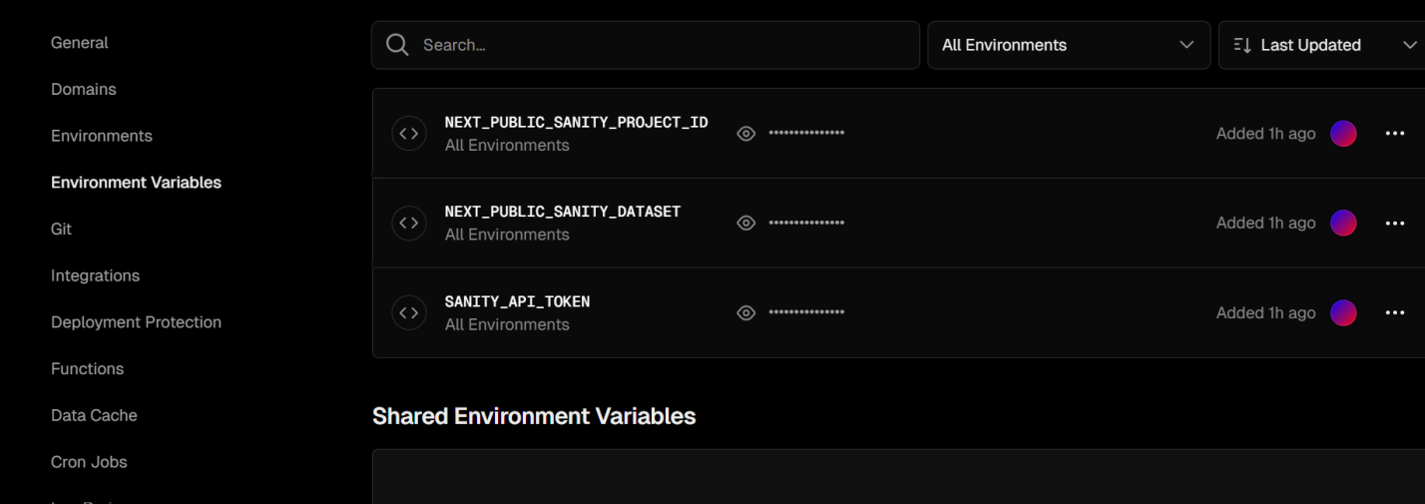

* **SSL and HTTPS enable by vercel**

[**https://vercel.com/sattarkhas-projects/nike-hackathon-cirt**](https://vercel.com/sattarkhas-projects/nike-hackathon-cirt)

* **Performance Optimization**

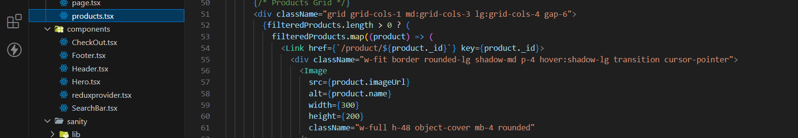

**Monitoring and Analytical tools**

Used sentry

const { withSentryConfig } = require("@sentry/nextjs");

const moduleExports = {

  // Your existing Next.js config here

};

const SentryWebpackPluginOptions = {

  silent: true, // Suppresses all logs

};

module.exports = withSentryConfig(moduleExports, SentryWebpackPluginOptions);